Assignment 5

Name: Johan Aanesen

Studnr: 473182

Github repo: <https://github.com/JohanAanesen/DataMod_oblig5>

I have collaborated with Daniel Bruun and Svein Are Danielsen

# Part I – Practicing XPath

### 1. Find the fall years (the node list of fallYear attributes) for the seasons stored in the XML

### document.

Query: //@fallYear

Result: 2 results, type fallYear attribute nodes

### 2. Find all the entries (the node list of Entry elements) logged by the user with user name

### mari_dahl.

Query: //Skier[@userName='mari_dahl']/Log/Entry

59 results, type Entry elements

### 3. Find the logs (the node list of Log elements) for skiers in the 2015 season who skied for the

### club with id vindil and who skied more than 10 (kilometres).

Query: //Season[@fallYear='2015']/Skiers[@clubId='vindil']/*/Log[sum(.//Distance)>10]

6 results, type Log elements

This result is based on that the skiers total distance is larger than 10, and not that one single distance is larger than 10. The hint wants only 5 elements can be achieved by removing the sum().

### 4. Find the user names (the node list of userName attributes) on skiers who in the 2016 season

### skied in an area having Venabygd as a part of the area name.

Query: //Season[@fallYear='2016']//*[contains(Area,'Venabygd')]/../../@userName

17 results, type userName attribute

### 5. Find number of skiers who are considered young juniors (i.e., they are born between 2002 and

### 2004).

Query: count(//Skier[YearOfBirth>='2002' and YearOfBirth<='2004'])

Result: 42

### 6. Find the dates (the node list of Date elements) during the season of 2015 where the skier with

### user name idar_kals1 skied in the are named Lygna.

Query: //Season[@fallYear='2016']//Skier[@userName='idar_kals1']/*/*[Area='Lygna']/Date

3 results, type Date elements

### 7. Find the total distance logged during the 2015 season.

Query: sum(//Season[@fallYear='2015']//Distance)

Result: 20164

### 8. Find the total distance logged in the season of 2015 by skiers who were not skiing for a given

### club in that season.

Query: sum(//Season[@fallYear='2015']/Skiers[not(@clubId)]//Distance)

Result: 587

### 9. Find the skiers in the skier list (the nodelist of SkierLogs/Skiers/Skier elements) who

### skied for an Oppland club in the season of 2015.

Query: //SkierLogs/Skiers/Skier[@userName=../../Season[@fallYear='2015']/Skiers[@clubId=../../Clubs/Club[County='Oppland']/@id]/Skier/@userName]

34 results, type Skier elements

### 10. Find the skiers in the skier list (the nodelist of SkierLogs/Skiers/Skier elements) who

### skied in the area with the name Nordseter in the 2015 season but not in the 2016 season.

Query: //SkierLogs/Skiers/Skier[@userName=../../Season[@fallYear='2015']/Skiers/Skier/*/Entry[Area='Nordseter']/../../@userName and not(@userName=../../Season[@fallYear='2016']/Skiers/Skier/*/Entry[Area='Nordseter']/../../@userName)]

5 results, type Skier element

# Part II - Using DOM and PDO to Import XML Data to MySQL

## Task 1 – Design the Database

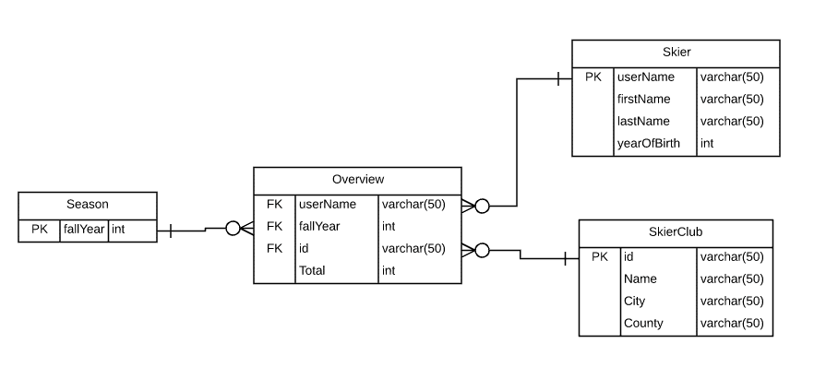

## Task 2 – Create the Database in MySQL

SQL file included in the repository.

## Task 3 – Importing XML Data to the Database

Code is in the index.php file in the repository